**TROOP 493**

**City Council Meeting 17 Aug 2021**

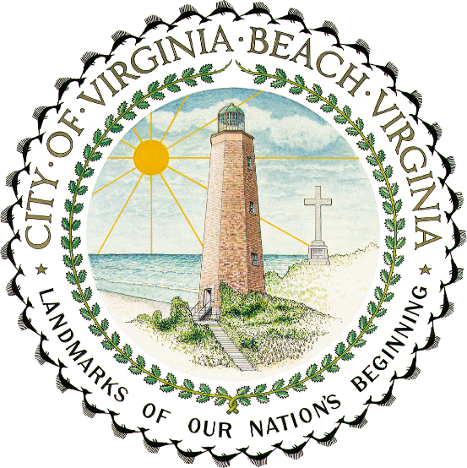 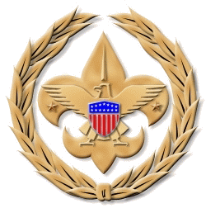

Troop was presented a copy of the attached proclamation thanking them for their attendance at the event

